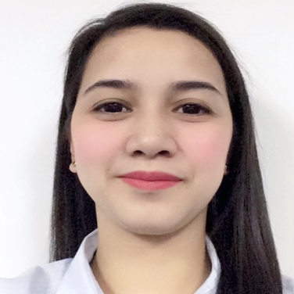**Donna Lou O. Gabat**

Block 7 Lot 27, Lansones Street, Legian IA Subdivision,

Carsadang bago II, Imus, Cavite

Email: donnalougabat[@gmail.com](mailto:policarpiorossane@google.com)

Cell Phone Number: 0915-656-5290

**CAREER OBJECTIVE:**

To find a job that will improve my capabilities, to enhance my skills and to have a good experience to communicate with other people.

**PERSONAL DATA:**

Age : 39 years old

Date of Birth : May 19, 1982

Sex : Female

Civil Status : Single

Religion : Roman Catholic

Blood Type : O

**WORKING EXPERIENCE:**

**Our Lady of the Pillar Medical Center**  August 2018 up to present

Tamsui Avenue, Bayan Luma, Imus, Cavite

**Health Information Management Staff**

**Medicard Philippines**  February 2015 – July 2018

**Claims Pro Philippines Inc**

The World Centre, Gil Puyat Makati City

**Medical/Claims Processor**

**Our Lady of the Pillar Medical Center**  November 2013- February 2015

Tamsui Avenue, Bayan Luma, Imus, Cavite

**Billing Staff**

**Affiliated Computer Services** December 2007- January 2013

Makati City

**Quality Control**

**MFOSYS INC.** August 2004 - December 2007

Muntinlupa, Alabang

**Quality Control**

**SKILLS:**

ICD-10 passer (November 25-29,2019)

Research Oriented

Familiarity in HMO related plans and benefits

Knowledgeable in , Diagnosis code,test materials, application, execution and interpretation

**Others:**

Flexible and adaptable to work duties

Accuracy and attention to details

Sufficient knowledge in MS Word, MS Power Point, MS Excel

Willingness to learn

**EDUCATIONAL BACKGROUND**

**Tertiary :** **Bachelor of Science of Computer Science** June 1998-March 2002 Major in Computer Science

Philippine Christian University

Pedro Gil Taft Avenue, Manila

**Secondary :** Felipe G. Calderon Integrated School June 1994-March 1998

Managuit, Tondo, Manila

**Primary :** Felipe G. Calderon Integrated School June 1989-March 1994

Managuit, Tondo, Manila

**CHARACTER REFERENCE:**

**Ms.Stephanie O. Salvador**

Contract Manager

Food Services

**Sodexo On the Site Phils., Inc.**

0917-807-8141

**Ms. Catherine Ramos**

Team Leader

**Claims Pro. Philippines Inc.**

0918-945-6382

**Mr. Rono Jel M. Felizardo**

Supervisor

Health Information Management Department

**Our Lady of the Pillar Medical Center**

0917-694-6472

I hereby that the data entered herein are true and correct according to the best of my knowledge.